PUBPOL 4390/5390 “Day 21 in-class exercise”
Group Names (all members): ___Thelonious Goerz__________________________________________

We will use the datasets “G” for training (not Gsmall!), and “H” for testing. Each one is a unique set of births from 2015.
- Combine Datasets G and H.

- We will predict birthweight (in grams). Let’s use a small-to-medium sized model of covariates. However (this is new) do not use gestation. The idea is that we’re making the prediction mid-pregnancy, and so we do not observe late-term variables. (This is just guidance; and aimed at making the prediction problem harder. It’s not critical for the in-class exercise.)

- Train a random forest model with 100 trees, each tree having a maximum depth of 10, and your algorithm’s default choices for (subsampling) and (feature sampling)

  - Figure out what those default choices are, so as to be able to report them
  - For future work, figure out how could manually change those tuning parameters

- I would like you to compare the following measures of goodness of fit. These can be reported in the first row of the able below. The units of GOF might depend on what your algorithm automatically computes for its OOB measure.
Note: In R it is not possible to set tree depth directly, however, we can set the number of observations in each leaf which is analogous (I look at 100, 10, and 3 observations per leaf.

What are the units of GOF? (eg. R2, MSE, other…) ________

 |  | In-sample GOF | OOB (in-sample) | Test-sample GOF
Random Forest | B=100, depth =10,min_n = 10 | 294 | 515 | 500
OLS |  | 515 | N/A | 506
Random Forest | B=100, depth =3, min_n = 100 | 499 | 511 | 498
Random Forest | B=100, depth =20, min_n = 3 | 209 | 516 | 501
For each of these models, the resulting number of tree depths are between 30 for the smallest and 48 for the most complex model.

- Try to create a variable importance plot; or some other a measure of “which variables are the most important in the forest.
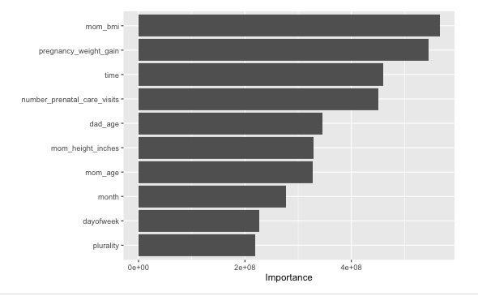
Excluding gestation_weeks, the consistently most important variables are weight, time and number of pre-care visits.

- Using the same set of features/covariates, how does OLS do?
OLS does a little worse in out of sample RMSE, but it is not by much.
- Try 2 new forests: one with a max depth of 3, and another with a max depth of 20. How do in-sample and test-sample results vary with this tuning parameter? How good is the OOB estimate, as a guide for how the relative test-sample performance does? (Does it get the rankings correct?)
Overall, the most complex model does the worst. While the medium and less complex models do about the same. The OOB estimate does get the ranking correct.
We will discuss together in class. Each group member should also upload a copy of their work to the class Canvas page under assignments. It’s OK for the group assignments to be identical among group members. Please make sure all group member names are on each person’s assignment.

